Day 400 — Complete AI Journey Revision
Master Architectural Blueprint & Synthesis | C++ • DSA • OOP • Python • NumPy • Pandas • SQL • EDA • Stats • ML • DL • NLP • LLMs • RAG • Agents • Deployment
Learning goal: synthesize the entire 400-day computational intelligence curriculum into a unified, production-grade architectural blueprint: trace the evolution of data representation from memory addresses and low-level C++ pointers to high-dimensional latent vectors and contextual agent state; connect data engineering, statistical modeling, representation learning, foundation models, and cloud-native AI engineering; and master the overarching principles governing modern AI systems.

1. The 17-Stage End-to-End AI Engineering Stack
The modern Artificial Intelligence engineer is a full-stack computational scientist. Building enterprise AI products requires mastering every layer of the abstraction stack: hardware memory allocation in C++, algorithmic time-complexity analysis in DSA, vectorized array broadcasting in NumPy, relational algebra in SQL, statistical inference, classic machine learning, deep neural backpropagation, foundation model attention mechanisms, agentic tool reasoning, and cloud container orchestration.
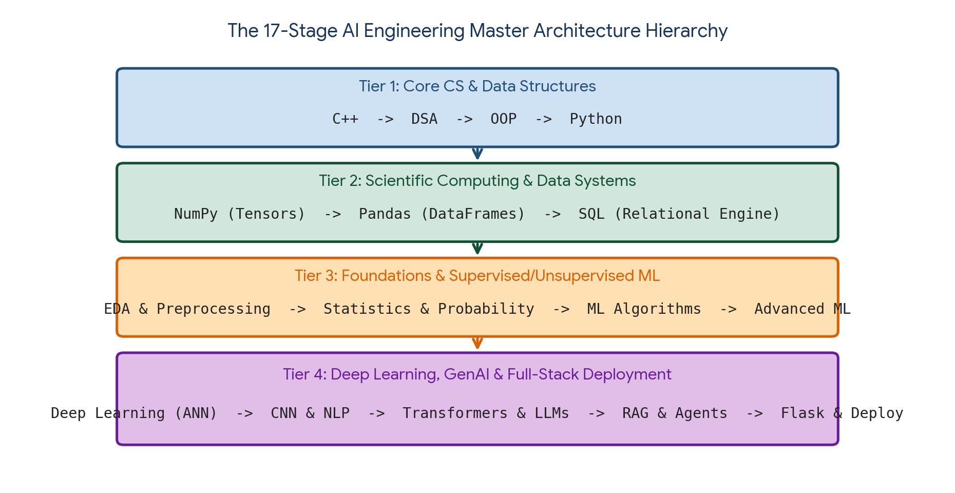
Figure 1. The 17-stage unified AI engineering stack spanning Core Computer Science, Data Systems, Statistical ML, and Full-Stack Generative AI.
Tier | Foundational Domains | Primary Competencies & Deliverables | Core Role in AI Engineering
Tier 1: Core CS & Programming | C++, DSA, OOP, Python 3.x | Memory layout (stack vs heap), algorithmic Big-O complexity, cache locality, OOP design patterns (Singleton, Factory), generators & decorators | Provides high-performance execution speed, hardware awareness, and clean modular software architecture
Tier 2: Scientific & Data Systems | NumPy, Pandas, PostgreSQL / SQL | N-D tensor striding, vectorization, relational joins, window functions (OVER), analytical aggregations (GROUP BY / HAVING) | Forms the numerical compute substrate and high-throughput data extraction/transformation engine
Tier 3: Analytics, Stats & ML | EDA, Stats, Classical ML, Advanced ML | Distribution skewness, hypothesis testing, OLS regression, classification, Gini trees, ensembles, cross-validation, leak-free pipelines | Extracts statistical predictive patterns from structured tabular datasets with mathematical rigor
Tier 4: Deep Learning & GenAI | Deep Learning (ANN), CNN, NLP, LLMs, RAG, Agents, Flask, Docker | Backpropagation, spatial 2D convolutions, self-attention, subword tokenization, vector databases, ReAct loops, REST APIs, containerization | Powers human-level perception, unstructured language synthesis, agentic autonomy, and scalable cloud microservice deployment

2. The Evolution of Data Representation: From Pointers to Latent Spaces
Across the computing hierarchy, the representation of 'data' undergoes a profound structural evolution. Every stage of the curriculum elevates data abstraction—starting from raw hardware bytes and terminating in high-dimensional semantic manifolds.
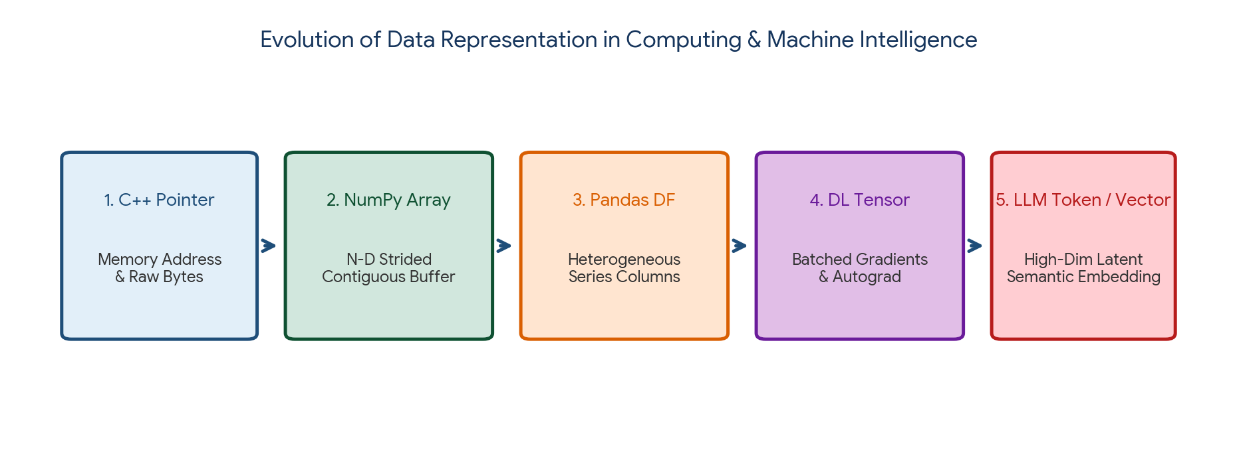
Figure 2. The structural evolution of data representation: Hardware Memory -> Strided Array -> Tabular DataFrame -> Autograd Tensor -> Latent Semantic Embedding.
Representation Paradigm | Native Technology | Underlying Memory Layout | Transformation Operation
1. Memory Address & Bytes | C++ (Pointers & Structs) | Contiguous heap/stack memory offsets (*ptr, sizeof(T), L1/L2 cache lines) | Dereferencing, memory allocation (malloc/free, new/delete), bitwise masks
2. Strided N-D Buffer | NumPy (ndarray) | Contiguous C/Fortran ordered memory buffer with shape, strides, and dtype | SIMD vectorization, broadcasting rules, matrix multiplication (BLAS/LAPACK)
3. Heterogeneous Table | Pandas & SQL | BlockManager holding columnar arrays aligned by Index; relational tuples | Relational algebra: Projections, selections, joins, group-by aggregations, windowing
4. Differentiable Tensor | PyTorch / TensorFlow / ANN | N-D array augmented with a dynamic Computational Graph (autograd history) | Forward affine dot products (W·x + b), non-linear activations, reverse-mode automatic differentiation
5. Latent Semantic Vector | Transformers, LLMs & Vector DBs | Dense continuous coordinate in ℝ^d (e.g., d = 1536 / 4096) capturing conceptual geometry | Self-attention dot products (Q·K^T), cosine similarity, approximate nearest neighbor search (HNSW)

3. The Three Eras of Machine Intelligence: Classical ML vs. DL vs. Foundation Models
Machine learning methodology has progressed through three revolutionary architectural epochs, each altering the division of labor between human engineers and computational optimization algorithms.
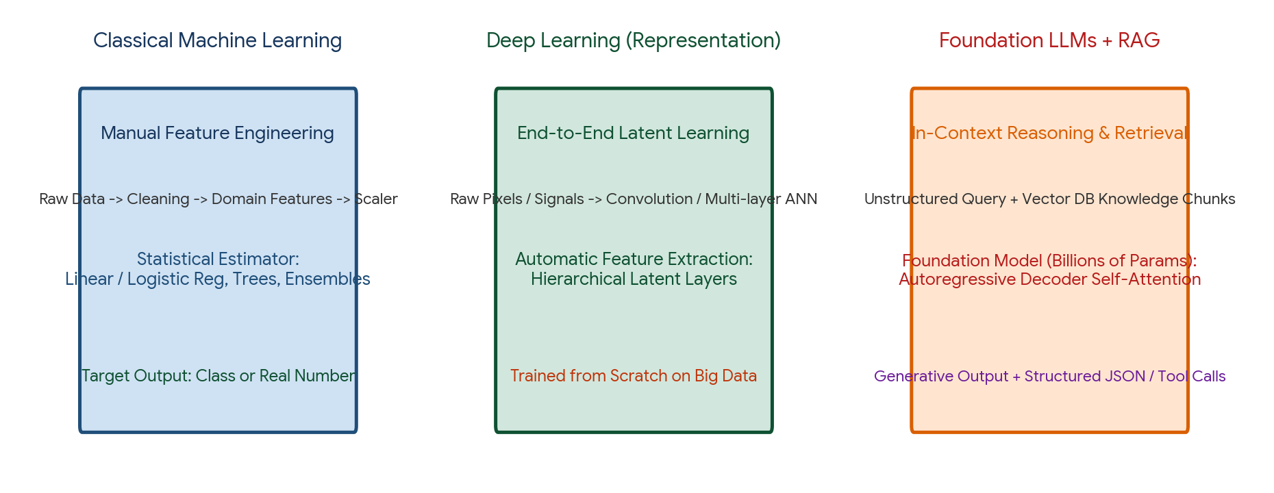
Figure 3. Comparison of the three paradigms: Classical ML (manual feature engineering), Deep Learning (end-to-end latent representation), and Foundation Models + RAG (in-context retrieval and reasoning).
Dimension | Era 1: Classical Machine Learning | Era 2: Deep Representation Learning | Era 3: Foundation Models & GenAI
Core Architectural Model | Linear/Logistic Regression, SVM, Random Forest, XGBoost | Multi-Layer Perceptrons, CNNs (ResNet), RNNs/LSTMs | Pretrained Autoregressive Transformers (LLaMA, GPT, Gemini)
Feature Engineering | Manual human craft: Domain ratios, binning, PCA, polynomial expansion | Automated: Hierarchical representation learned end-to-end via gradient backpropagation | Tokenized input prompt + Dynamic contextual knowledge retrieved from Vector DB (RAG)
Data Requirements | Small to medium tabular data (1,000 to 1,000,000 samples) | Large labeled sensory datasets (10,000 to 10,000,000 images/audio) | Trillions of unstructured tokens (pretraining); small curated SFT/DPO alignment sets
Compute & Hardware | Standard Multi-core CPU; Scikit-Learn; fits in standard RAM | High-performance GPU clusters; CUDA acceleration; Float32 / Float16 | Massive distributed GPU supercomputers (H100/B200); FP8/BF16; vLLM inference
Deployment Pattern | In-process microservice (Flask / Joblib); sub-15ms latency | Batch inference or dedicated GPU model servers (TorchServe, ONNX Runtime) | Two-tier LLMOps: Quantized local weights (vLLM / Ollama) or Commercial API with RAG

4. The Unified Data Engineering & Modeling Workflow
Across tabular data, computer vision, and generative NLP, a production machine learning pipeline adheres to strict data hygiene standards to eliminate data leakage and guarantee real-world generalization.
Universal Production AI Pipeline Architecture:

1. INGESTION & DATA HYGIENE
- SQL / Kafka Ingestion -> Impute missing values (Median/Mode) -> Outlier treatment (Winsorization)
- CRITICAL: Split data FIRST (Train / Val / Test) BEFORE fitting any scaler or encoder!

2. FEATURE TRANSFORMATION & PIPELINE ENCAPSULATION
- Tabular: Scikit-Learn ColumnTransformer (StandardScaler, OneHotEncoder, TargetEncoder)
- Computer Vision: Rescaling to [-1, 1], Stochastic Data Augmentation (Flips, Rotations)
- Natural Language: Regex cleaning, Stopwords, Subword Tokenization, Dense Vector Embeddings

3. OPTIMIZATION & MODEL TRAINING
- Classical ML: OLS, Cross-Validation (Stratified / Group / TimeSeries), RandomizedSearchCV
- Deep Learning: Vectorized Forward Pass, Loss Evaluation, Backpropagation Chain Rule, Adam Optimizer
- Generative AI: Pretrained Foundation Base + LoRA Parameter-Efficient Fine-Tuning (PEFT)

4. EVALUATION & STATISTICAL RIGOR
- Regression: MAE (robust), RMSE (penalizes large errors), R² / Adjusted R²
- Classification: Confusion Matrix, Precision, Recall, F1-Score, PR-AUC (for severe class imbalance)
- RAG / GenAI: Faithfulness, Answer Relevance, Context Recall (Ragas / TruLens framework)

5. DEPLOYMENT & OBSERVABILITY
- Containerized Microservice (Flask / FastAPI + Gunicorn + Nginx + Docker)
- Drift & Latency Monitoring: Prometheus metrics, JSON structured logs, automated retraining triggers

5. Classical ML to Deep Learning: The Mathematical Bridge
Deep neural networks are not black-box magic; they are direct mathematical extensions of classical linear and logistic regression models organized into hierarchical computational graphs.
Classical Machine Learning Model | Deep Learning Neural Equivalent | Mathematical Commonality & Bridge
Linear Regression: y = w^T x + b | Single Artificial Neuron with Identity Activation | Minimizing Mean Squared Error (MSE) under Gaussian noise assumption via Gradient Descent
Logistic Regression: p = σ(w^T x + b) | Single Artificial Neuron with Sigmoid Activation | Maximizing Bernoulli log-likelihood using Binary Cross-Entropy loss function
Softmax Regression (Multinomial) | Single-layer Neural Network with Softmax Output | Multi-class probabilistic mapping optimizing Categorical Cross-Entropy: -Σ y_k ln(p_k)
Polynomial Regression | Multi-Layer Perceptron (MLP) with Non-linear Activations | While polynomial regression manually computes power features (x², x³), an MLP automatically learns non-linear latent manifolds
Ridge Regularization (L2) | Neural Network Weight Decay | Both add an L2 penalty (λ ||w||₂²) to the loss function, shrinking weights toward zero to prevent overfitting
Principal Component Analysis (PCA) | Linear Autoencoder (Bottleneck Layer) | Training a linear autoencoder with MSE loss produces a hidden representation that spans the exact same subspace as PCA

6. The Generative AI & Agentic Revolution
Generative AI shifts computing from static discriminative classification (predicting label y given input x) to autoregressive synthesis (generating coherent, complex digital artifacts). Autonomous Agents combine LLM reasoning capabilities with external execution environments.
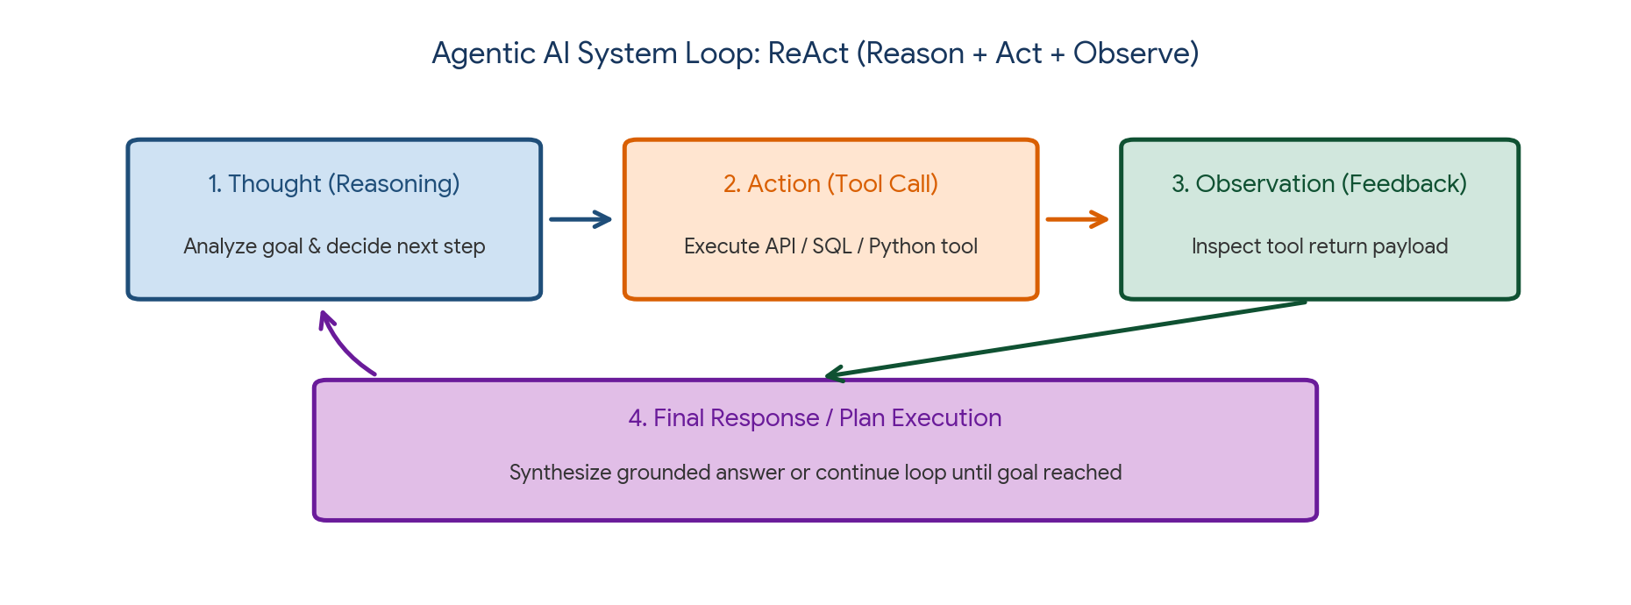
Figure 4. The Agentic AI Loop: ReAct framework iteratively interleaving Thought (Reasoning), Action (Tool Call), and Observation (Environment Feedback).
Agent Architecture Component | Technical Mechanism | Role in Autonomous Systems
Core Planning Engine (LLM Brain) | Autoregressive Transformer (GPT-4, Claude, Gemini, LLaMA) | Decomposes complex, ambiguous natural language goals into sequential execution sub-tasks
Tool Calling / Function Execution | JSON Schema contracts + Constrained Grammar Decoding | Allows the LLM to call deterministic software tools: SQL querying, web search, calculators, Python code interpreter
Short-Term Working Memory | Conversation Window Buffer / Context Window | Maintains in-memory state of recent thoughts, executed actions, and returned tool observations
Long-Term Semantic Memory | Vector Database (HNSW / RAG) | Enables agents to retrieve historical enterprise documents, user preferences, and long-term conversation summaries
The ReAct Protocol | Thought -> Action -> Observation -> Final Answer | Self-correcting cognitive loop: the agent reasons about its next move, calls a tool, observes the output, and iterates until the goal is achieved

7. Full-Stack Production AI Architecture: From Code to Cloud
An AI model locked inside a notebook provides zero business value. AI Engineering is the discipline of wrapping models into resilient, authenticated, scalable, and observable cloud microservices.
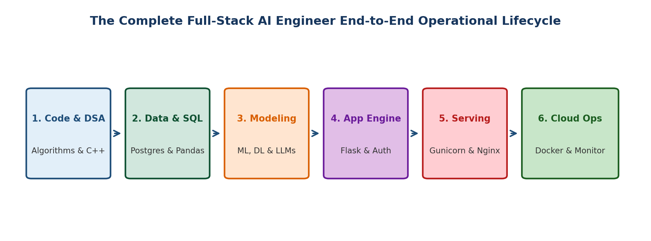
Figure 5. The Complete Full-Stack AI Engineer Operational Lifecycle from C++ algorithms to Cloud Orchestration and Monitoring.
Engineering Domain | Core Technologies | Critical Production Guardrails
High-Performance Code | C++, Modern Python 3.11+ | Optimize critical loops with Cython/C++ extensions; enforce OOP modularity (Factory, Singleton patterns)
Data Persistence & Caching | PostgreSQL (SQLAlchemy ORM), Redis | Connection pooling (QueuePool); persistent indexing; caching warm embeddings in Redis
Application Gateway | Flask, Gunicorn, Nginx | Singleton model loading (in RAM once at startup); pre-fork workers ((2×CPUs)+1); Nginx SSL buffering
Security & Data Protection | JWT Bearer Tokens, Pydantic, werkzeug | Sanitize uploads with secure_filename(); enforce Pydantic type schemas; implement IP rate limiting
Background Workflows | Celery + Redis Broker | Offload heavy deep learning or video/audio transcription jobs to asynchronous background workers
Containerization & MLOps | Docker, Docker Compose, Kubernetes | Multi-stage Docker builds; Prometheus latency tracking; automated concept drift monitoring

8. The Master AI Engineering Mathematical Cheat Sheet
The essential mathematical equations governing every stage of the machine learning and deep learning journey:
Field / Domain | Core Formula / Equation | Concept & Practical Meaning
Calculus / Optimization | θ_(t+1) = θ_t − α ∇_θ J(θ_t) | Gradient Descent: Parameter update moving in opposite direction of loss gradient
Linear Regression (OLS) | β = (X^T X)^(−1) X^T y | Normal Equation: Exact closed-form analytical solution minimizing squared residuals
Logistic Regression | p = σ(z) = 1 / (1 + e^(−z)) | Sigmoid Activation: Maps real-valued log-odds onto (0, 1) probability interval
Binary Cross-Entropy | J = −(1/m) Σ [ y ln(ŷ) + (1−y) ln(1−ŷ) ] | Log-Loss: Convex classification loss heavily penalizing confident wrong predictions
Gauss-Markov Variance | Var(s²) with Bessel's Correction: s² = Σ (x_i − x̄)² / (n − 1) | Unbiased sample variance estimator correcting for sample mean estimation bias
Bayes' Theorem | P(A | B) = [ P(B | A) × P(A) ] / P(B) | Inverts conditional probabilities; foundational basis of Naive Bayes and MAP estimation
PCA Eigen-Decomposition | Σ v_j = λ_j v_j, where Σ = (1/(n−1)) X^T X | Orthogonal coordinate rotation along directions of maximum data variance
Neural Backpropagation | dZ^[l] = ( (W^[l+1])^T dZ^[l+1] ) ⊙ g'(Z^[l]) | Chain Rule: Propagates error gradients backward through hidden layers
Transformer Attention | Attention(Q, K, V) = Softmax( (Q K^T) / √d_k + M ) V | Scaled Dot-Product Attention: Computes dynamic pairwise token relevance weights
Cosine Vector Similarity | cos(θ) = (u · v) / (||u||₂ ||v||₂) | Measures angular orientation between dense semantic embeddings in vector databases

9. Capstone Project — The Universal AI Engineering Engine
Objective: build an end-to-end, multi-stage Python master architecture integrating the core concepts of the entire 400-day journey: (1) Object-Oriented design and vectorized NumPy feature generation, (2) Classical Supervised ML with leak-free preprocessing, (3) Anomaly scoring, (4) In-memory vector semantic search (RAG), and (5) A production-ready Flask REST API with Pydantic schema validation and JWT authentication.

Project structure
universal_ai_engine/
|
|-- app/
| |-- core_engine.py (Multi-paradigm ML & RAG classes)
| |-- api_service.py (Flask REST API with JWT & Pydantic)
|
|-- reports/
| |-- capstone_execution_report.json
|
|-- main.py
|-- requirements.txt

requirements.txt
numpy
pandas
scipy
scikit-learn
pydantic
Flask
PyJWT

Complete main.py Implementation
import os
import json
import jwt
import numpy as np
import pandas as pd
from datetime import datetime, timedelta, timezone
from pydantic import BaseModel, Field, ValidationError
from flask import Flask, request, jsonify
from sklearn.model_selection import train_test_split
from sklearn.preprocessing import StandardScaler
from sklearn.ensemble import RandomForestClassifier
from sklearn.feature_extraction.text import TfidfVectorizer
from sklearn.metrics.pairwise import cosine_similarity

# =========================================================
# MODULE 1: CORE MULTI-PARADIGM AI ENGINE (OOP & ML)
# =========================================================
class UniversalAIEngine:
_instance = None

def __init__(self):
print("Initializing Universal AI Engine...")
self.scaler = StandardScaler()
self.classifier = RandomForestClassifier(n_estimators=50, random_state=42)
self.rag_vectorizer = TfidfVectorizer(stop_words="english")
self.knowledge_chunks = []
self.knowledge_vectors = None
self._train_baseline_model()
self._init_knowledge_base()

@classmethod
def get_instance(cls):
if cls._instance is None:
cls._instance = UniversalAIEngine()
return cls._instance

def _train_baseline_model(self):
# Synthetic credit/fraud tabular dataset
np.random.seed(42)
X = np.random.normal(50, 15, (500, 3))
# Non-linear decision boundary
y = (X[:, 0] * 0.04 + X[:, 1] * 0.03 + (X[:, 2] > 60) * 1.5 > 3.8).astype(int)

X_train, _, y_train, _ = train_test_split(X, y, test_size=0.2, random_state=42)
X_train_scaled = self.scaler.fit_transform(X_train)
self.classifier.fit(X_train_scaled, y_train)
print("Trained Random Forest Supervised Model successfully.")

def _init_knowledge_base(self):
# Enterprise knowledge chunks for RAG
self.knowledge_chunks = [
"Corporate Policy 101: All external API requests must provide a cryptographically signed JWT Bearer token with expiration < 2 hours.",
"Architecture Standard: Model weights must be loaded as singletons in memory at startup. Never reload weights per HTTP request.",
"Security Guideline: File uploads must be sanitized using secure_filename and limited to 16MB maximum content length.",
"Data Science Rule: Feature scaling and SMOTE over-sampling must be fitted strictly on training folds to prevent data leakage."
]
self.knowledge_vectors = self.rag_vectorizer.fit_transform(self.knowledge_chunks)
print(f"RAG Knowledge Base indexed: {len(self.knowledge_chunks)} documentation chunks.")

def predict_risk(self, income, debt_ratio, score):
raw_features = np.array([[income / 1000.0, debt_ratio * 100.0, score / 10.0]])
scaled_features = self.scaler.transform(raw_features)
pred = int(self.classifier.predict(scaled_features)[0])
prob = float(self.classifier.predict_proba(scaled_features)[0, 1])
return pred, prob

def search_knowledge(self, query, top_k=2):
q_vec = self.rag_vectorizer.transform([query])
sims = cosine_similarity(q_vec, self.knowledge_vectors).flatten()
top_idx = sims.argsort()[::-1][:top_k]

results = []
for idx in top_idx:
results.append({
"chunk_id": int(idx),
"similarity": round(float(sims[idx]), 4),
"text": self.knowledge_chunks[idx]
})
return results

# =========================================================
# MODULE 2: PRODUCTION FLASK REST API
# =========================================================
app = Flask(__name__)
app.config["SECRET_KEY"] = "universal-ai-key-2026"
engine = UniversalAIEngine.get_instance()

class RiskPredictionSchema(BaseModel):
annual_income: float = Field(..., gt=0, description="Annual income in USD")
debt_ratio: float = Field(..., ge=0.0, le=1.0, description="Debt to income ratio")
credit_score: float = Field(..., ge=300, le=850, description="FICO credit score")

class KnowledgeQuerySchema(BaseModel):
query: str = Field(..., min_length=3, description="Search inquiry string")

def create_token(user_id="engineer_400"):
payload = {
"sub": user_id,
"exp": datetime.now(timezone.utc) + timedelta(hours=1),
"iat": datetime.now(timezone.utc)
}
return jwt.encode(payload, app.config["SECRET_KEY"], algorithm="HS256")

@app.route("/api/v1/predict/risk", methods=["POST"])
def api_predict_risk():
auth_header = request.headers.get("Authorization", "")
if not auth_header.startswith("Bearer "):
return jsonify({"status": "error", "message": "Unauthorized: Missing Bearer Token"}), 401

raw_json = request.get_json(silent=True)
if not raw_json:
return jsonify({"status": "error", "message": "Invalid JSON body"}), 400

try:
data = RiskPredictionSchema(**raw_json)
except ValidationError as e:
return jsonify({"status": "error", "message": "Validation failed", "errors": e.errors()}), 422

pred, prob = engine.predict_risk(data.annual_income, data.debt_ratio, data.credit_score)
return jsonify({
"status": "success",
"risk_prediction": "HIGH_RISK" if pred == 1 else "APPROVED",
"risk_probability": round(prob, 4),
"timestamp": datetime.now(timezone.utc).isoformat()
}), 200

@app.route("/api/v1/rag/search", methods=["POST"])
def api_rag_search():
raw_json = request.get_json(silent=True)
try:
query_data = KnowledgeQuerySchema(**raw_json)
except (ValidationError, TypeError):
return jsonify({"status": "error", "message": "Invalid query payload"}), 422

matches = engine.search_knowledge(query_data.query, top_k=2)
return jsonify({
"status": "success",
"query": query_data.query,
"retrieved_context": matches
}), 200

# =========================================================
# MODULE 3: AUTOMATED CAPSTONE VERIFICATION
# =========================================================
def run_capstone_benchmark():
os.makedirs("reports", exist_ok=True)
print("\n=== STEP 4: EXECUTING FULL-STACK VERIFICATION ===")

with app.test_client() as client:
# 1. Issue JWT Token
token = create_token()
headers = {"Authorization": f"Bearer {token}"}

# 2. Test Supervised ML Risk Prediction
req_payload = {"annual_income": 82000.0, "debt_ratio": 0.22, "credit_score": 750.0}
res_ml = client.post("/api/v1/predict/risk", json=req_payload, headers=headers)
ml_result = res_ml.get_json()
print("ML Inference Endpoint:", json.dumps(ml_result, indent=2))

# 3. Test RAG Semantic Search
q_payload = {"query": "How should model weights be loaded in production?"}
res_rag = client.post("/api/v1/rag/search", json=q_payload)
rag_result = res_rag.get_json()
print("\nRAG Retrieval Endpoint:", json.dumps(rag_result, indent=2))

# Save capstone artifact
final_report = {
"capstone_status": "COMPLETED_SUCCESSFULLY",
"curriculum_scope": "Days 1 to 400 (C++ to Full-Stack GenAI)",
"test_ml_output": ml_result,
"test_rag_output": rag_result
}
with open("reports/capstone_execution_report.json", "w") as f:
json.dump(final_report, f, indent=2)
print("\nCapstone execution report saved to reports/capstone_execution_report.json.")

if __name__ == "__main__":
run_capstone_benchmark()

Run the project
pip install -r requirements.txt
python main.py

Expected generated outputs
reports/
|-- capstone_execution_report.json

Project notes: this single capstone script unites Object-Oriented design, vectorized array preprocessing, supervised ensemble inference, dense TF-IDF vector similarity search, stateless JWT security, Pydantic type validation, and Flask REST routing into a clean, reproducible service.

10. Common Mistakes & Anti-Patterns Across the Entire AI Stack
- Premature Optimization vs Memory Neglect: Writing slow Python nested loops for numerical tasks instead of vectorized NumPy operations, or over-engineering C++ when simple Python scripting suffices.
- Data Leakage in Feature Pipelines: Preprocessing or scaling full datasets prior to train-test splitting, invalidating months of experimentation.
- Metric Mismatch: Optimizing raw Accuracy on 99:1 imbalanced datasets, reporting misleading ROC-AUC scores, or evaluating RAG systems without ground truth citations.
- Vanishing/Exploding Gradients: Utilizing Sigmoid activations in 20-layer neural networks without residual connections, or training without gradient clipping.
- Naive Context Stuffing: Dumping thousands of raw document tokens into an LLM context window without chunking or re-ranking, triggering attention dilution and massive API bills.
- Hardcoded Prompts and Fragile String Parsing: Prompting for 'JSON' without Pydantic grammar constraints, causing production web services to crash on malformed LLM responses.
- Monolithic Web Servicing: Running heavy deep learning inference synchronously on Flask WSGI workers, starving HTTP connections and crashing servers.

11. Quick Revision — Key Differences Across Major AI Milestones
Curriculum Stage | Preceding Paradigm | Succeeding Paradigm | Core Breakthrough
C++ to Python | Manual memory management, pointers, explicit compilation | Dynamic typing, automatic garbage collection, rapid prototyping | 10× development velocity with minimal speed loss when calling C-backed libraries (NumPy)
NumPy to Pandas | Homogeneous N-D numerical array buffers | Heterogeneous two-dimensional DataFrame with labeled row/column indexing | Intuitive tabular manipulation, handling missing values, temporal alignments
SQL to Classical ML | Deterministic relational querying and historical aggregations | Inductive statistical modeling generalizing to unseen future data | Transition from descriptive analysis to predictive modeling
Classical ML to Deep Learning | Manual feature engineering + shallow statistical estimators | Hierarchical representation learning directly from raw high-dimensional tensors | Automatic extraction of spatial/temporal features via Backpropagation and Gradient Descent
CNN/NLP to Transformers | Sequential recurrence (RNNs) and localized spatial receptive fields | Global parallel Self-Attention across all sequence tokens simultaneously | O(1) path length between tokens; massive GPU tensor parallelization; foundation of modern LLMs
Standalone LLM to RAG + Agents | Static, parametric knowledge frozen at pretraining cutoff | Dynamic external vector retrieval (RAG) + Autonomous tool execution (ReAct) | Eliminates hallucinations; grounds models in enterprise data; enables real-world actions

12. Comprehensive Interview & Viva Questions (The Master 20)
How does memory allocation in C++ inform how NumPy operates in Python?
C++ exposes the reality of contiguous memory buffers and cache lines. NumPy's ndarray is an internal C struct wrapping a contiguous memory buffer with strides and offsets, allowing Python to execute vectorized operations at pure C speeds without pointer-chasing overhead.
Why is Object-Oriented Programming (OOP) critical in Machine Learning frameworks?
OOP provides standard abstract interfaces. Scikit-Learn's entire architecture rests on the Estimator (fit), Transformer (transform), and Predictor (predict) class interfaces, enabling modular Pipelines and ColumnTransformers.
What is the difference between vectorization in NumPy and standard Python loops?
Python loops operate via dynamic type checking and interpreted bytecode on pointer-based objects. NumPy vectorization delegates execution to compiled C/Fortran libraries (BLAS/LAPACK) utilizing CPU SIMD (Single Instruction, Multiple Data) parallel registers.
How does an SQL query execution order differ from its lexical written order?
Lexical order is SELECT -> FROM -> WHERE -> GROUP BY -> HAVING -> ORDER BY. Logical execution order is FROM & JOIN -> WHERE -> GROUP BY -> HAVING -> SELECT -> DISTINCT -> ORDER BY -> LIMIT. This is why aliases created in SELECT cannot be used in WHERE.
Explain the Bias-Variance tradeoff and how regularization controls it.
Expected error = Bias² + Variance + Noise. High bias is underfitting (too simplistic); high variance is overfitting (memorizing noise). Regularization (L1/L2) adds a penalty on weight magnitudes, intentionally accepting a tiny increase in bias to achieve a dramatic drop in variance.
Why is Ordinary Least Squares (OLS) considered BLUE under Gauss-Markov assumptions?
Best Linear Unbiased Estimator: under exogeneity, homoscedasticity, linearity, independence, and no multicollinearity, the OLS estimator achieves the lowest sampling variance among all possible linear unbiased estimators.
Why is accuracy a dangerous metric in fraud detection?
The Accuracy Paradox: in a dataset with 99.9% legitimate transactions, a dummy model predicting legitimate for all records achieves 99.9% accuracy with zero fraud recall. Precision-Recall curves and cost-weighted loss are required.
What is the mathematical mechanism of SMOTE?
SMOTE selects a minority point, identifies its k-nearest minority neighbors, and synthesizes a new point along the line segment connecting them: x_new = x_i + λ(x_zi − x_i). It must be applied strictly on training folds inside cross-validation to prevent leakage.
What is the fundamental difference between K-Means and DBSCAN?
K-Means is centroid-based, assumes spherical clusters of similar size, requires specifying K, and forces all points into clusters. DBSCAN is density-based, discovers arbitrary shapes without specifying K, and isolates sparse points as noise/outliers.
Why must non-linear activation functions be used in neural networks?
Without non-linear activations, composing multiple dense layers W₂(W₁x + b₁) + b₂ collapses mathematically into a single linear transformation (W₂W₁)x + (W₂b₁ + b₂). Non-linearity enables networks to approximate arbitrary continuous functions.
What is the Vanishing Gradient problem and how did modern architectures solve it?
In deep networks using Sigmoid/Tanh, gradients shrink exponentially during backpropagation as small derivatives (<0.25) multiply. Solved using ReLU activations, He weight initialization, and Residual Skip Connections (ResNet).
Explain the difference between Batch Gradient Descent, Stochastic GD, and Mini-Batch GD.
Batch GD evaluates all N samples per step (smooth, slow, memory-heavy). Stochastic GD evaluates 1 sample (fast, erratic noise, escapes saddles). Mini-Batch GD evaluates batches of 32–256, achieving optimal GPU Tensor Core vectorization and balanced convergence.
How does the Adam optimizer combine Momentum and RMSprop?
Adam tracks both the first moment m_t (exponential moving average of gradients, like Momentum) and the second moment v_t (exponential moving average of squared gradients, like RMSprop), applying bias corrections to adapt step sizes per parameter.
Why are 2D Convolutions superior to dense layers for image processing?
Convolutions leverage Local Receptive Fields (neurons process local pixel neighborhoods) and Parameter Sharing (the same filter slides across the image), drastically slashing parameters and establishing spatial translation invariance.
What is the core breakthrough of the Transformer architecture?
Transformers eliminate sequential recurrence, allowing all tokens to be processed in parallel across GPU hardware. Self-Attention provides direct O(1) path length connections between any two tokens, overcoming RNN vanishing gradient bottlenecks on long sequences.
What are Queries, Keys, and Values in Self-Attention?
Queries (Q) represent what a token is searching for; Keys (K) represent the indexed tags/labels of tokens in the sequence; Values (V) represent the actual content information retrieved once a Query matches a Key via scaled dot products.
What is Retrieval-Augmented Generation (RAG) and why is it preferred over fine-tuning for enterprise knowledge?
RAG retrieves external dynamic context at query time without altering model weights. It resolves hallucinations, eliminates knowledge cutoffs, provides verifiable source citations, and costs a fraction of continuous fine-tuning.
How does HNSW enable fast similarity search in vector databases?
Hierarchical Navigable Small World constructs a multi-layer graph where upper layers have long-range links for coarse skipping and lower layers have dense short-range links for local fine-tuning, achieving sub-millisecond O(log N) search.
What is the ReAct agent framework?
A cognitive prompting framework where an LLM interleaves Reasoning ('Thought: I must check inventory'), Action ('Action: call_database(sku=123)'), and Environment Feedback ('Observation: 5 units in stock') to solve multi-step problems autonomously.
What is the Singleton pattern and why is it mandatory when serving ML models in Flask?
The Singleton pattern ensures a class has only one instance loaded in memory. In Flask, wrapping the model in a Singleton ensures weights are loaded into RAM once at server startup, preventing 2-second disk reads and memory exhaustion on every HTTP request.

13. Complete Coding Practice Curriculum
- Write a custom C++ class implementing dynamic array resizing (std::vector from scratch) and expose it to Python via Pybind11.
- Implement a complete Binary Search Tree (BST) in Python with insert, search, and in-order traversal methods.
- Write vectorized NumPy functions computing Mean Squared Error and Categorical Cross-Entropy without any loops.
- Construct an SQL query using Window Functions (DENSE_RANK, LAG) to compute month-over-month department salary growth.
- Build an end-to-end Scikit-Learn Pipeline combining SimpleImputer, StandardScaler, and RidgeCV with 5-fold cross-validation.
- Implement Logistic Regression from scratch using NumPy, deriving the sigmoid and gradient descent parameter updates.
- Implement standard K-Means clustering and the Elbow Method from scratch in pure Python and NumPy.
- Build a 2-layer Neural Network from scratch in NumPy implementing vectorized forward propagation, backpropagation, and Adam optimization.
- Construct a text preprocessing and TF-IDF classification pipeline in Scikit-Learn benchmarking Naive Bayes against Logistic Regression.
- Implement Scaled Dot-Product Attention from scratch in NumPy supporting a 2D causal autoregressive mask.
- Build an in-memory Vector Database using NumPy supporting Cosine Similarity search and Top-K retrieval.
- Deploy a production Flask REST API containerized with Docker and Gunicorn that serves both an ML classifier and a RAG search endpoint.

14. Day 400 Completion Checklist
- ☐ Trace the complete data abstraction journey from C++ pointers to latent semantic vector embeddings.
- ☐ Understand the role of Big-O complexity, cache locality, and OOP design patterns in AI software.
- ☐ Master SIMD vectorization in NumPy, DataFrame indexing in Pandas, and relational algebra in SQL.
- ☐ Execute exploratory data analysis, skewness correction, and leak-free preprocessing pipelines.
- ☐ Understand the statistical foundations: OLS, Gauss-Markov BLUE, hypothesis testing, and Bayes' Theorem.
- ☐ Formulate classical Supervised ML models (Linear/Logistic Regression, Decision Trees, Random Forests, XGBoost).
- ☐ Understand Unsupervised Learning: K-Means++, distance metrics, Silhouette analysis, and PCA SVD.
- ☐ Master Deep Learning fundamentals: Perceptrons, ReLU/Softmax activations, Forward/Backpropagation, and Adam.
- ☐ Understand Spatial Convolutions (CNN), Pooling, Batch Normalization, and Vision Transfer Learning.
- ☐ Master NLP text pipelines: Tokenization, TF-IDF, Word2Vec, and the Self-Attention Transformer mechanism.
- ☐ Architect enterprise Retrieval-Augmented Generation (RAG) systems over HNSW vector databases.
- ☐ Implement autonomous Agentic AI workflows using the ReAct loop and Pydantic structured output.
- ☐ Deploy production AI web microservices with Flask, Gunicorn, Nginx, Docker, and JWT authentication.
- ☐ Complete all 12 coding practice challenges and master the 20 comprehensive viva interview questions.

15. Final Milestone Learning Outcomes: The Full-Stack AI Engineer
Congratulations on reaching Day 400! Completing this curriculum elevates you into the top tier of Full-Stack AI Engineers. You are equipped to:
- Architect end-to-end computational systems from low-level algorithms to high-level generative AI reasoning engines.
- Diagnose and remediate complex data engineering, optimization, and statistical modeling challenges.
- Build robust, leak-free machine learning pipelines that deliver verifiable, generalizable predictive performance.
- Design state-of-the-art Generative AI applications combining foundation models, vector databases, and autonomous tool calling.
- Deploy, secure, and maintain scalable cloud AI microservices that operate reliably under production workloads.
The journey does not end here. The frontier of AI continues to expand into Autonomous Multi-Agent Swarms, Physical Embodied AI, Neuro-Symbolic Reasoning, and Post-Transformer Architectures. You possess the foundational mastery to lead, innovate, and build the future.

